
FACULTY OF TECHNOLOGY AND ENGINEERING
DEVANG PATEL INSTITUTE OF ADVANCE TECHNOLOGY
AND RESEARCH

DEPARTMENT OF COMPUTER ENGINEERING

A.Y 2026 – 27 Semester – 3

LAB MANUAL

CSUC201 Fundamentals of Data Structures and Algorithms

Practical 9: Graph Traversal: Depth-First Search and
Breadth-First Search

Practical Aim
To implement depth-first and breadth-first traversal on a graph and develop the ability to reasonabout how the order of exploration changes depending on the traversal strategy used
Problem 1
A disaster relief team needs to inspect all buildings in a city after an earthquake. The city ismapped as a network where buildings are connected by roads. One team starts at a buildingand goes as deep into each road as possible before backtracking, while a second team spreadsout level by level — first checking all buildings directly connected to the start, then all buildingstwo roads away, and so on. Given the city map as a graph and a starting building, implementboth exploration strategies and print the order in which buildings are visited by each team.
Describe how the order of buildings visited differs between the two strategies on the samegraph. What data structure does each strategy rely on to decide which building to visit next, andhow does that structure cause the difference in order?

For Code:

Output:
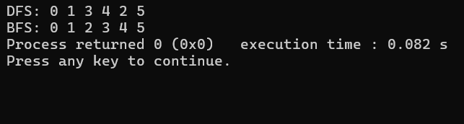

Problem 2
A school library uses a system where every book is assigned a unique code when it arrives.
Books are organized so that at any shelf position, all books to the left have smaller codes and
all books to the right have larger codes. This arrangement lets staff find any book quickly by
always knowing which direction to look. Given a sequence of book codes arriving one by one,
insert each into the correct position and print the inorder sequence after all insertions are
complete.
For Code:
Output:
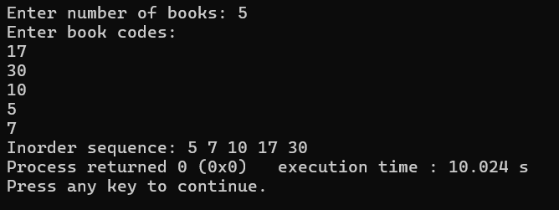
Outcome/Conclusion:
Students will be able to implement DFS and BFS on a graph, explain how the underlying data structure used by each strategy determines the order of traversal, and apply graph traversal logic to detect structural properties such as cycles in an undirected graph.

Key Questions / Analysis / Interpretation to be Evaluated During/After Implementation
- [Problem 1] A circular array is one way to reuse freed slots without shifting all elements.
Without implementing it, explain what change would need to be made to your front and
rear pointer logic to make the array behave circularly, and what new condition would
indicate a full array.
Ans:- The front and rear pointers should wrap around to the beginning when they reach the end of the array, using modulo logic. The array is full when (rear + 1) % size == front.

- [Problem 2] Your linked list stack has no fixed capacity limit. But in practice, can it still
run out of space? What determines the actual limit, and why is that limit invisible in your
code?
Ans:- Yes, a linked list stack can still run out of space. Its limit depends on the available system memory (heap). This limit is not fixed in the code because nodes are created dynamically until memory is exhausted.

- [Problem 3] operator precedence determines the order in which operators are placed
into the output. Without tracing any expression, explain what would go wrong in your
output if your solution treated all operators as having equal precedence.
Ans:- If all operators have equal precedence, operators would be processed in the wrong order. For example, multiplication might not be performed before addition, resulting in an incorrect postfix expression and wrong final result.

